Machine Learning-Based Forecasting of Hydroclimatic Water Stress in Eswatini: A Catchment-Scale Remote-Sensing and Climate-Data Approach

Abstract
Eswatini faces recurrent droughts and substantial hydroclimatic variability, creating a need for reliable short-term forecasting approaches in data-sparse environments. This study developed a leakage-controlled machine learning framework for one-month-ahead forecasting of a standardized three-month climatic water-balance anomaly in the MnJoli W60E catchment using CHIRPS and ERA5-Land environmental data. Monthly precipitation, potential evapotranspiration, temperature, soil moisture, runoff, solar radiation, and related variables were combined with lagged and accumulated predictors. Climatic standardization was derived exclusively from the training period, and model development followed a chronological training–validation–test design. Training-based feature ranking and validation-based selection identified 15 predictors, while Ridge Regression with α = 0.05 was selected before independent testing. Over the January 2024–December 2025 test period, the model achieved MAE = 0.9625, RMSE = 1.3906, and R² = 0.2124, reducing RMSE by 20.84% relative to persistence and 20.93% relative to climatology. Antecedent soil moisture, precipitation, and evaporative-demand variables provided important predictive signals, although performance deteriorated for the small number of extreme anomalies. These results demonstrate measurable short-term forecast skill while highlighting the need for longer records, improved extreme-event modelling, and spatial extension before operational application.
Keywords: Hydroclimatic forecasting; water stress; Ridge Regression; remote sensing; climate reanalysis; Eswatini; drought early warning

Chapter 1: Introduction
1.1 Background
Water resources in Southern Africa are critically sensitive to the increasing frequency and intensity of climate variability. Eswatini, a landlocked nation in the region, faces significant hydrological challenges characterized by recurrent droughts, rising temperatures, and shifting rainfall patterns. These factors contribute to severe water stress, directly impacting rainfed agriculture, national food security, energy production, and domestic supply. Historical events, such as the catastrophic 1991/92 drought, underscore how interannual climate fluctuations can destabilize the socio-economic fabric of the country, leading to reservoir depletion and widespread agricultural failure (Hadebe & Dube, 2024).
Eswatini’s climate is subtropical, exhibiting considerable spatial and temporal variability. Precipitation ranges from approximately 1,500 mm in the northern Highveld to a mere 400 mm in the southern Lowveld (Eswatini Government & UNCCD, 2020 ). This climatic gradient means that deviations from normal hydroclimatic conditions can produce substantial differences in water availability across the country, particularly in regions with high dependence on rainfed agriculture. Projections indicate that climate change may increase the frequency, duration, and intensity of drought events, further increasing pressure on the
country’s water resources (World Bank, 2021).
Water stress is influenced by multiple interacting climatic and hydrological variables rather than precipitation alone. Temperature affects atmospheric evaporative demand, while potential evapotranspiration (PET), soil moisture, precipitation, runoff, and atmospheric moisture conditions collectively influence the availability and persistence of water. Consequently, a data-driven assessment of water stress requires the integration of multiple environmental variables and their temporal behaviour.
The increasing availability of satellite-derived and climate reanalysis datasets provides an opportunity to address this challenge in countries where ground-based environmental observations are limited. Precipitation products, soil moisture estimates, atmospheric variables, surface runoff, and energy-related observations can be combined to construct a more comprehensive representation of the hydroclimatic conditions affecting water stress. Machine learning techniques provide flexible approaches for integrating multiple environmental predictors and representing complex hydroclimatic relationships. Such approaches are particularly valuable where precipitation, temperature, evapotranspiration, soil moisture, runoff, atmospheric conditions, and antecedent environmental states may collectively contain information about future hydroclimatic conditions.
In the present study, Ridge Regression is used to model regularized linear predictive relationships among correlated environmental variables, while temporal feature engineering is used to incorporate lagged and accumulated environmental information.

1.2 Problem Statement
Despite the clear vulnerability of Eswatini to hydroclimatic extremes, water-stress and drought management remains largely dependent on monitoring historical conditions and responding after significant deficits have developed. Such approaches are valuable for diagnosing previous events but provide limited predictive information for anticipating future water-stress conditions. The ability to forecast changes in water stress before they become severe would support more informed decisions relating to agricultural planning, water allocation, reservoir management, and climate-risk preparedness.
Furthermore, there remains a significant research gap concerning data-driven water-stress forecasting specifically within Eswatini. Recent studies have applied machine learning techniques to drought prediction in localized areas such as the Maguga Basin (Fashoto et al., 2025). However, localized forecasting approaches do not necessarily capture the broader combination of climatic and hydrological conditions influencing water stress at the national scale.
A further challenge is the strong interdependence among environmental predictors. Temperature, potential evapotranspiration, precipitation, soil moisture, runoff, and their lagged or cumulative forms are often highly correlated. While these relationships contain useful information about the hydroclimatic system, they can introduce substantial multicollinearity into predictive models and make it difficult to determine which variables provide the most meaningful predictive contribution.
There is therefore a need for a systematic machine learning framework that integrates multiple environmental predictors, evaluates their predictive contribution, and explicitly considers temporal dependencies and multicollinearity. Such a framework can provide not only predictions of water-stress conditions but also evidence concerning the environmental factors most strongly associated with changes in water stress in Eswatini.

1.3 Rationale and Significance
This research is grounded in the strategic priorities of Eswatini’s National Drought Plan (2020), which calls for improved monitoring and early-warning systems to strengthen national climate resilience. By moving beyond retrospective description towards predictive modelling, this study investigates how machine learning can be used to anticipate changes in hydroclimatic water-stress conditions from observed environmental patterns.

The significance of this study lies in its:
- Multi-variable Integration: Combining precipitation, potential evapotranspiration, temperature, soil moisture, runoff, surface runoff, solar radiation, and related environmental variables to represent the interacting processes associated with hydroclimatic water stress.
- Temporal Feature Engineering: Incorporating lagged environmental variables and multi-month accumulated indicators to capture delayed and cumulative effects within the hydroclimatic system.
- Genuine One-Month-Ahead Forecasting: Using environmental information available in the current month to forecast standardized hydroclimatic water-balance conditions one month ahead, while maintaining chronological separation between model development and independent testing.
- Model Interpretation: Examining standardized Ridge Regression coefficients to assess the relative predictive contribution of selected environmental variables while recognizing the influence of correlated hydroclimatic processes.
- Management of Predictor Redundancy: Addressing the substantial correlation among current, lagged, and accumulated environmental predictors through parsimonious feature selection and Ridge regularization.
- Practical Relevance: Evaluating forecast skill against persistence and climatological baselines to determine whether environmental information provides useful predictive value beyond simpler forecasting approaches, thereby providing evidence relevant to future climate-risk monitoring and water-resource management in Eswatini.

1.4 Research Objectives
The primary objective of this study is to develop and evaluate a machine learning-based framework for one-month-ahead forecasting of hydroclimatic water-stress conditions in Eswatini using multi-source environmental and climate-derived data.
The specific objectives are:
- To construct a standardized climatic water-balance anomaly from monthly precipitation and potential evapotranspiration as the target variable for one-month-ahead hydroclimatic forecasting.
- To identify the lagged and multi-month accumulated environmental variables that provide useful predictive signals for one-month-ahead forecasting of hydroclimatic water stress.
- To engineer temporal predictors, including lagged and multi-month accumulated environmental variables, to capture delayed and cumulative hydroclimatic effects.
- To develop and evaluate a regularized Ridge Regression model for one-month-ahead forecasting using chronologically separated training, validation, and independent testing periods.
- To examine the relative predictive contribution of the selected environmental variables using standardized Ridge Regression coefficients.
- To address predictor redundancy and multicollinearity through feature selection and Ridge regularization and to evaluate whether the resulting forecasting model provides predictive skill relative to persistence and climatological baselines.

1.5 Research Questions
- Which environmental variables provide the strongest predictive information for one-month-ahead forecasting of hydroclimatic water stress?
- To what extent do lagged and multi-month accumulated environmental variables contribute useful information for forecasting future water-stress conditions?
- To what extent can a regularized Ridge Regression model provide one-month-ahead forecast skill relative to persistence and climatological baseline forecasts?
- Which environmental variables make the strongest relative contributions within the final forecasting model, and how should these contributions be interpreted in the presence of correlated hydroclimatic predictors?
1.6 Study Area Map
Figure 1.1 illustrates the study area, highlighting the Kingdom of Eswatini’s four major physiographic regions: the mountainous Highveld in the west, the Middleveld, the semi-arid Lowveld, and the Lubombo Plateau in the east. These regions exhibit substantial differences in elevation, climate, vegetation, and hydrological conditions, making Eswatini an appropriate study area for investigating the environmental controls of water stress.
The map also identifies the major river systems and other important hydrological features that contribute to the country’s agricultural, domestic, and economic water resources. The spatial variation in environmental conditions across these regions provides important context for interpreting the hydroclimatic variables used in the forecasting framework.

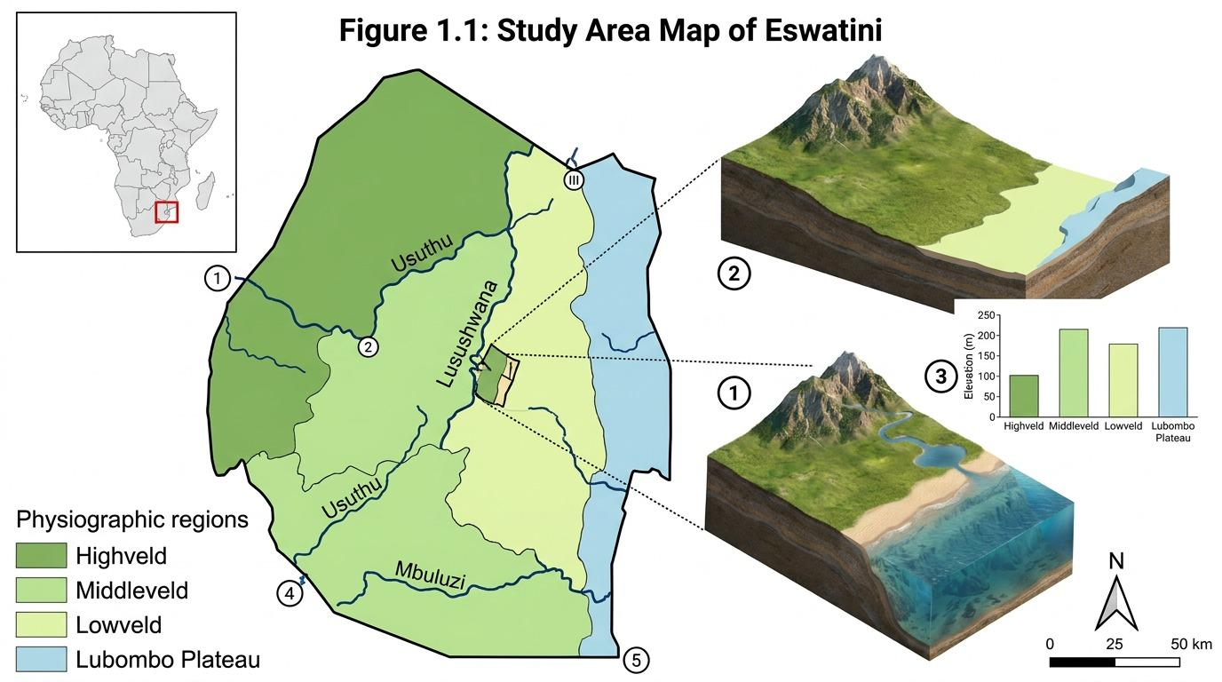
Figure 1.1: Study Area Map of Eswatini showing major physiographic regions,
hydrological features, and the geographical context of the study.
1.7 Scope and Delimitations
The study investigates hydroclimatic water-stress forecasting using environmental observations representing the study catchment in Eswatini. The analysis is therefore designed as a catchment-scale temporal forecasting case study rather than a spatially resolved forecasting model for the entire country. The broader environmental and water-resource conditions of Eswatini provide the geographical and management context within which the forecasting framework is interpreted.
The study uses monthly environmental observations covering January 2015 to December 2025. Following temporal feature engineering and construction of the one-month-ahead forecasting target, the final forecasting dataset contained 126 usable monthly observations. Of these, 102 observations were ultimately available for final model development after combining the training and validation periods, while 24 monthly forecasts covering January 2024 to December 2025 were retained for independent out-of-sample evaluation.
The analysis focuses on forecasting a standardized three-month climatic water-balance anomaly derived from precipitation and potential evapotranspiration. This indicator represents hydroclimatic departures from training-period calendar-month conditions and is used as the dependent variable for one-month-ahead forecasting. It should therefore be interpreted as an indicator of hydroclimatic water-balance conditions rather than as a direct measurement of socioeconomic or operational water scarcity.
Predictor variables include precipitation, potential evapotranspiration, temperature, dew point, soil moisture, runoff, surface runoff, solar radiation, wind speed, atmospheric pressure, seasonal indicators, lagged variables, and multi-month accumulated variables. Environmental information available at month t is used to forecast the standardized climatic water-balance anomaly at month t+1.
The study does not attempt to directly forecast reservoir storage, streamflow, groundwater availability, agricultural yield, irrigation demand, household water consumption, or infrastructure-related water availability. Consequently, the resulting forecasts should not be interpreted as direct predictions of water-security outcomes.
Furthermore, the analysis focuses on temporal prediction and does not claim to provide spatially resolved forecasts across the Highveld, Middleveld, Lowveld, and Lubombo Plateau. Differences in forecast performance among these regions are therefore outside the scope of the present study. Spatial characteristics of Eswatini are used primarily to provide geographical and hydroclimatic context for interpreting the study.
Because the predictor variables contain substantial temporal and physical interdependence, predictor redundancy and multicollinearity are explicitly considered during model development. Correlation-based feature ranking, validation-based feature-count selection, predictor standardization, and Ridge regularization are used to obtain a parsimonious forecasting model while reducing instability associated with highly correlated environmental variables.
1.8 Broader Impact and Ethical Considerations
This research contributes to Sustainable Development Goal 6 (Clean Water and Sanitation) and Sustainable Development Goal 13 (Climate Action) by investigating data-driven approaches for improved understanding and forecasting of water stress.
The study relies primarily on open-access environmental and climate datasets, thereby supporting reproducibility and reducing dependence on costly ground-based monitoring infrastructure. The proposed forecasting framework may provide a foundation for future early-warning applications by identifying environmental conditions associated with increasing water stress.
From an ethical perspective, model outputs should be interpreted as decision-support information rather than as definitive predictions of future water availability. Particular care is required when communicating uncertainty, especially where forecasts may influence agricultural, environmental, or water-allocation decisions. Feature-importance results are similarly interpreted as model-based associations rather than direct evidence of physical causation.
1.9 Thesis Structure
Chapter 1: Introduction – Presents the background, problem statement, rationale, research objectives, research questions, study area, scope, and significance of the study.
Chapter 2: Literature Review – Reviews drought and water-stress assessment, environmental and remote-sensing datasets, machine learning approaches, temporal feature engineering, predictor redundancy, regularization, and approaches to model interpretation in hydroclimatic forecasting.
Chapter 3: Methodology – Describes the environmental dataset, construction of the standardized climatic water-balance anomaly, temporal feature engineering, one-month-ahead target construction, leakage prevention, chronological data partitioning, feature selection, Ridge Regression development, baseline forecasts, evaluation metrics, and model-interpretation procedures.
Chapter 4: Results and Discussion – Presents feature-selection and hyperparameter-selection results, independent forecast performance, comparisons with persistence and climatological baselines, residual and sensitivity analyses, temporal variation in forecasting performance, and interpretation of standardized Ridge coefficients.
Chapter 5: Conclusion and Recommendations – Summarizes the major findings, discusses implications for climate-resilient water-resource management, identifies study limitations, and provides recommendations for future research and operational development.

Chapter 2: Literature Review
2.1 Introduction
This chapter provides a critical synthesis of literature concerning water-stress assessment, hydroclimatic indicators, environmental and remote-sensing data, and the application of machine learning to water-stress forecasting. Particular attention is given to the role of temperature, precipitation, potential evapotranspiration (PET), soil moisture, runoff, atmospheric moisture, and solar radiation in determining hydroclimatic conditions. The chapter also examines the importance of temporal feature engineering, feature selection, predictor correlation, regularization, and approaches to model interpretation in environmental forecasting.
The review considers international and Southern African studies, with particular attention to research relevant to Eswatini. It establishes the theoretical and methodological basis for developing a data-driven water-stress forecasting framework using monthly environmental observations.
2.2 Water Stress and Hydroclimatic Variability
Water stress occurs when the demand for water exceeds the available supply or when the quality and timing of available water are insufficient to satisfy human, agricultural, ecological, and economic requirements. At the environmental level, water stress is strongly influenced by the balance between precipitation inputs and atmospheric water demand. Temperature, evapotranspiration, soil moisture, surface runoff, and antecedent precipitation therefore play important roles in determining the persistence and severity of water deficits.
In Southern Africa, water availability is highly sensitive to climatic variability. Droughts and prolonged dry periods can reduce soil moisture, groundwater recharge, streamflow, and reservoir inflows, while increasing temperatures can increase evaporative demand. The interaction between these processes means that water stress cannot always be adequately represented using precipitation alone (Chivangulula et al., 2023).
Eswatini is particularly vulnerable because of its strong climatic and topographic gradients. Differences in elevation, rainfall, temperature, and land characteristics produce substantial spatial variation in water availability. The Eswatini National Drought Plan identifies drought and climate variability as significant threats to agriculture, water resources, livelihoods, and national development (Eswatini Government & UNCCD, 2020). Consequently, forecasting water stress requires consideration of multiple hydroclimatic variables and their interactions rather than relying exclusively on single-variable drought indicators.
2.3 Drought and Water-Stress Indices
A range of standardized indices has been developed to quantify drought and water deficits. The Standardized Precipitation Index (SPI) is one of the most widely used indicators and is based primarily on precipitation anomalies. Although SPI is useful for identifying meteorological drought, it does not explicitly account for changes in atmospheric evaporative demand.
The Standardized Precipitation Evapotranspiration Index (SPEI) extends this approach by incorporating potential evapotranspiration. This makes SPEI particularly relevant under changing climatic conditions where increasing temperature can intensify atmospheric water demand even when precipitation changes are relatively limited (Chivangulula et al., 2023 ).
Different accumulation periods provide information about different components of the hydrological system. Short accumulation periods are generally more responsive to agricultural and soil-moisture conditions, whereas longer periods may better represent accumulated hydrological deficits. SPEI-3 has therefore frequently been applied to investigate short-term drought conditions and agricultural water stress (Phiri et al., 2025).
However, standardized drought indices are themselves derived from combinations of environmental variables. Consequently, machine learning models that attempt to predict an index may learn strong relationships with the same environmental variables used in its construction. This makes careful feature selection and interpretation particularly important when developing predictive models.
Although SPEI provides an established probabilistic framework for drought characterization, the present study employs a related but computationally simpler standardized water-balance anomaly. The index standardizes the three-month accumulated precipitation–PET balance relative to the historical mean and standard deviation for each calendar month. It therefore preserves the central principle of evaluating water availability relative to climatological conditions while avoiding the assumption that the resulting indicator is formally equivalent to SPEI.
2.4 Environmental and Remote-Sensing Predictors of Water Stress
The increasing availability of satellite observations and climate reanalysis products has created new opportunities for environmental monitoring in data-sparse regions. Satellite and reanalysis datasets can provide continuous spatial and temporal information on precipitation, soil moisture, temperature, radiation, and other hydroclimatic variables.
CHIRPS provides high-resolution precipitation estimates and has been widely used for drought monitoring, particularly in regions with limited ground observations (Funk et al., 2015). ERA5-Land provides a broad range of land-surface and atmospheric variables suitable for hydroclimatic analysis (Muñoz-Sabater et al., 2021).
The usefulness of these datasets is not limited to direct measurements of rainfall. Environmental water stress is influenced by a combination of atmospheric, surface, and subsurface processes. Temperature determines part of the atmospheric energy available for evaporation, while PET represents atmospheric evaporative demand. Soil moisture provides an indication of water stored within the land surface, whereas runoff represents the movement of water away from the land surface.
Research in Southern Africa has demonstrated strong relationships between drought conditions and vegetation, soil, and climatic responses. Lawal et al. (2022), for example, investigated the response of leaf area index to drought in southern African vegetation and demonstrated that drought conditions can produce measurable changes in vegetation functioning.
These findings support a multi-variable approach in which environmental predictors are combined rather than considered independently.
2.5 Temperature and Atmospheric Moisture as Drivers of Water Stress
Temperature is an important component of hydroclimatic variability because increases in temperature can increase evaporative demand and accelerate the depletion of available surface and soil water. Under warming conditions, temperature may therefore influence water stress even when precipitation does not decline substantially.
Atmospheric moisture conditions are also important. Dew point provides an indication of atmospheric moisture content and can complement temperature in representing the atmospheric conditions under which evaporation occurs. Together, temperature and dew point can provide information concerning both thermal conditions and atmospheric moisture availability.
Previous drought research has increasingly recognized that temperature-related variables should be incorporated into drought assessment because warming can amplify water deficits. The inclusion of temperature and atmospheric moisture variables is therefore particularly relevant to machine learning models designed to forecast water stress.
2.6 Temporal Dependence and Feature Engineering
Hydroclimatic processes exhibit strong temporal dependence. Conditions in a given month may be influenced by environmental conditions occurring during previous months. For example, a period of low precipitation may reduce soil moisture and runoff, while accumulated rainfall over several months may influence water availability even after rainfall returns to normal levels. Temporal feature engineering provides a mechanism for representing these dependencies within conventional machine learning models. Lagged variables represent previous observations, while rolling or accumulated variables capture conditions over longer periods.
In the present study, predictors include one-, two-, and three-month lagged variables as well as three- and six-month accumulated indicators for selected environmental variables. These features are intended to capture both immediate and delayed relationships between environmental conditions and water stress.
Temporal feature engineering is particularly useful when relatively small datasets are available because it allows conventional machine learning models to represent aspects of temporal behaviour without requiring highly complex deep learning architectures.
2.7 Machine Learning for Hydroclimatic Forecasting
Machine learning techniques have increasingly been applied to drought and hydroclimatic forecasting because of their ability to model non-linear relationships between environmental predictors and target variables.
Traditional statistical approaches often rely on assumptions concerning the form of relationships between predictors and outcomes. In contrast, machine learning algorithms can identify complex interactions among multiple environmental variables. This is particularly useful in hydroclimatic systems where temperature, precipitation, evapotranspiration, soil moisture, and runoff interact dynamically.
Recent research has demonstrated the potential of machine learning for drought forecasting in Southern Africa. Fashoto et al. (2025) applied machine learning to drought and dam-water-level prediction in the Maguga Basin of Eswatini, while Phiri et al. (2025) investigated SPEI-3 forecasting using ensemble machine learning and deep learning in South Africa.
These studies demonstrate the applicability of machine learning to regional drought forecasting while also highlighting the importance of model selection and predictor construction.
2.7.1 Tree-Based and Regularized Models
Tree-based algorithms such as Random Forest and gradient-boosting approaches such as XGBoost are widely used for environmental prediction because they can capture non-linear relationships and interactions between predictors. They are also capable of handling heterogeneous environmental variables without requiring strict assumptions about the underlying relationships.
Regularized linear models provide an alternative approach when the primary objective includes both prediction and interpretation. Ridge regression, for example, introduces an L2 penalty that reduces the magnitude of regression coefficients. This can improve model stability when predictors are strongly correlated. In environmental datasets, where multiple lagged versions of the same variable may contain overlapping information, regularization can be particularly useful. Rather than completely removing correlated variables, Ridge regression retains them while shrinking their coefficients towards zero.
This characteristic makes Ridge regression suitable for investigating the relative contribution of groups of highly correlated environmental predictors while reducing coefficient instability.
2.7.2 Deep Learning and Time-Series Models
Long Short-Term Memory (LSTM) networks have been widely applied to hydrological and drought forecasting because of their ability to model sequential dependencies. LSTM architectures can learn relationships across multiple time steps without explicitly requiring the researcher to construct every lagged variable.
Recent studies have demonstrated the potential of LSTM and hybrid deep learning architectures for drought prediction. Nyamane et al. (2024), for example, applied deep learning approaches to meteorological drought forecasting in the Northern Cape of South Africa. Chen et al. (2025) further demonstrated the potential of spatiotemporal LSTM architectures for drought prediction.
However, deep learning models generally require larger datasets than simpler machine learning approaches to reliably estimate a large number of parameters. Where the available dataset is relatively small, regularized models and tree-based methods may provide a more appropriate balance between predictive performance, computational requirements, and interpretability.
2.8 Multicollinearity in Environmental Prediction
Multicollinearity occurs when predictor variables are strongly correlated with one another. This is particularly common in environmental datasets because many variables represent related physical processes or are derived from the same underlying climatic conditions.
The problem becomes more pronounced when lagged and accumulated predictors are introduced. For example, current temperature and temperature values from the preceding months are expected to be strongly correlated. Similarly, three-month precipitation totals may contain substantial information already represented by monthly precipitation variables.
Variance Inflation Factor (VIF) is one conventional approach for diagnosing multicollinearity, with values above 5 or 10 often used as indicative thresholds (Gujarati & Porter, 2009). However, the present study does not use VIF-based predictor elimination. Instead, predictor redundancy is addressed through training-based correlation ranking, validation-based feature-count selection, and Ridge regularization, which is particularly suitable where correlated predictors may retain useful forecasting information.
High multicollinearity does not necessarily mean that a predictive model is invalid. Rather, it indicates that individual coefficient estimates may become unstable or difficult to interpret because several predictors contain overlapping information.
This distinction is important in the present study because the candidate environmental predictors include multiple current, lagged, and accumulated forms of precipitation, PET, runoff, surface runoff, soil moisture, temperature, and other related variables. Substantial predictor correlation is therefore expected. In such circumstances, regularization provides an appropriate modelling strategy because it can reduce coefficient instability without requiring all correlated predictors to be removed from consideration.
2.9 Feature Selection and Regularization
Feature selection is an important component of machine learning workflows because the inclusion of excessive or redundant predictors can increase model complexity and reduce interpretability.
Correlation-based feature selection provides a simple initial approach by identifying predictors that have strong associations with the target variable. However, correlation alone does not account for relationships between predictors. A variable may exhibit a strong correlation with the target while providing little unique information because another predictor contains similar information.
Regularization provides an alternative strategy. Ridge regression reduces the magnitude of coefficients associated with correlated predictors through an L2 penalty. This allows groups of related variables to remain in the model while reducing coefficient instability.
In the present study, correlation-based feature ranking is combined with validation-based feature-count selection and Ridge regularization. Candidate predictors are initially ranked according to their association with the forecasting target, while alternative predictor-set sizes are evaluated using chronologically subsequent validation data. Ridge regularization is then used to reduce coefficient instability associated with the correlated structure of the selected environmental predictors. This approach is particularly appropriate given the temporal structure of the dataset and the relatively large number of engineered predictors compared with the available observations.
2.10 Explainable Artificial Intelligence in Hydroclimatic Modelling
A major limitation of complex machine learning models is their potential lack of interpretability. Predictive accuracy alone may not be sufficient for water-resource decision-making because managers and policymakers need to understand the environmental conditions contributing to a forecast.
Explainable Artificial Intelligence (XAI) provides methods for interpreting machine learning predictions. SHAP (SHapley Additive exPlanations), for example, estimates the contribution of individual features to model predictions. LIME (Local Interpretable Model-agnostic Explanations) provides local approximations of complex models to explain individual predictions.
XAI has increasingly been applied to environmental and hydroclimatic modelling to identify the relative contribution of variables such as temperature, precipitation, soil moisture, and evapotranspiration (Britton et al., 2024).
In the context of water-stress forecasting, explainability is particularly important because strong predictive relationships do not automatically imply physical causation. Model interpretation should therefore be used to identify predictive patterns and dominant environmental signals rather than to claim direct causal relationships.
Although advanced explainable artificial intelligence techniques such as SHAP and LIME provide valuable approaches for interpreting complex nonlinear models, the present study employs Ridge Regression as its final forecasting model. Model interpretation is therefore based primarily on standardized Ridge coefficients rather than post-hoc XAI methods. Because the selected environmental predictors remain correlated, coefficient magnitudes are interpreted as indicators of relative predictive contribution within the fitted model rather than as estimates of independent causal effects.

2.11 Synthesis of Recent Machine Learning Studies
Table 2.1 summarizes selected studies relevant to machine learning-based drought and water-stress prediction.
Table 2.1: Synthesis of Recent ML-Drought Studies
Study | Region | Target | Model | Key Finding
Fashoto et al. (2025) | Eswatini (Maguga) | SPEI / Water Level | GA-LSTM vs ARIMA | GA-optimized LSTM outperformed ARIMA for drought and dam-water-level prediction.
Phiri et al. (2025) | South Africa | SPEI-3 | Ensemble ML / Deep Learning | Ensemble models demonstrated strong performance for short-term drought prediction.
Chen et al. (2025) | Mainland China | SPEI | STAT-LSTM | Spatiotemporal feature aggregation improved drought prediction across SPEI scales.
Nyamane et al. (2024) | South Africa | SPEI | CNN-LSTM | Combining spatial and temporal representations improved drought forecasting performance.
Afan et al. (2024) | Arid Region | SPEI | LSTM | Integration of remote-sensing variables improved drought prediction in a data-sparse environment.
The reviewed studies demonstrate that machine learning has considerable potential for hydroclimatic forecasting. However, most studies focus on either localized areas or datasets with substantially different climatic and geographical characteristics from Eswatini. Furthermore, relatively limited attention has been given to the combined problem of temporal feature engineering, strong predictor multicollinearity, regularized modelling, and interpretation of environmental feature groups within a single Eswatini-focused framework.
2.12 Knowledge Gaps
The literature review identifies several gaps that motivate the present study. First, much of the available drought forecasting research in Southern Africa is concentrated in South Africa, with relatively limited research focusing on Eswatini. Although Fashoto et al. (2025) provide an important Eswatini-specific contribution, their study is focused on the Maguga Basin and does not address the broader environmental predictor structure investigated in the present research.
Second, many existing studies emphasize complex deep learning architectures without sufficiently examining the redundancy introduced by lagged and aggregated environmental variables. This creates a need for systematic management of predictor redundancy and multicollinearity through feature selection and regularization.
Third, the relative importance of different environmental predictor groups remains insufficiently documented for Eswatini. In particular, the combined contribution of temperature, atmospheric moisture, runoff, PET, soil moisture, solar radiation, and precipitation requires further investigation.
Finally, there remains a need to bridge predictive modelling and practical interpretation. A forecasting framework that identifies not only whether water stress is likely to increase but also which environmental signals contribute most strongly to the prediction may provide greater value for climate-resilience planning.
2.13 Conceptual Framework
The conceptual framework for this study is based on the assumption that hydroclimatic water stress is influenced by interacting atmospheric, land-surface, and hydrological conditions.
Environmental observations including precipitation, temperature, potential evapotranspiration, soil moisture, runoff, surface runoff, solar radiation, wind speed, atmospheric pressure, and related variables are first integrated into a structured monthly dataset. A standardized climatic water-balance anomaly is constructed from precipitation and potential evapotranspiration to represent departures from calendar-month hydroclimatic conditions.
Temporal feature engineering is subsequently used to generate lagged and accumulated predictors representing antecedent environmental conditions. A one-month-ahead forecasting target is created so that environmental information available at month t is used to forecast the standardized water-balance anomaly at month t+1.
Candidate predictors are ranked using their training-period associations with the forecasting target, and alternative feature-set sizes are evaluated using chronologically subsequent validation observations. Ridge Regression is then applied to the selected predictor set to reduce coefficient instability associated with correlated environmental variables.
Forecast performance is evaluated on an independent test period using MAE, RMSE, and R² and is compared with persistence and climatological-normal baseline forecasts. Standardized Ridge coefficients are subsequently examined to assess the relative predictive contribution of the selected environmental variables, while avoiding causal interpretation of correlated predictors.
The conceptual relationship can therefore be summarized as:
Environmental Conditions
→ Climatic Water-Balance Construction
→ Temporal Feature Engineering
→ One-Month-Ahead Target Construction
→ Training-Based Feature Ranking
→ Validation-Based Feature Selection and Ridge Regularization
→ Independent Forecast Evaluation
→ Standardized Coefficient Interpretation
→ Water-Resource Management Insights
2.14 Chapter Summary
This chapter reviewed the theoretical and empirical literature supporting the development of a machine learning framework for water-stress forecasting in Eswatini. The literature demonstrates that water stress is influenced by interacting climatic and hydrological variables, including precipitation, temperature, PET, soil moisture, runoff, and atmospheric moisture.
Remote-sensing and climate-reanalysis products provide valuable environmental information in regions where ground observations are limited. Machine learning encompasses both linear and nonlinear predictive approaches. While nonlinear algorithms can represent complex environmental interactions directly, regularized linear methods such as Ridge Regression provide a parsimonious alternative when datasets are relatively small and predictors are strongly correlated. Temporal feature engineering further allows antecedent and cumulative hydroclimatic conditions to be incorporated into predictive models.
However, the use of multiple current, lagged, and accumulated predictors introduces substantial redundancy and correlation among environmental variables. Parsimonious feature selection and regularization are therefore important components of a robust forecasting framework. Ridge Regression is particularly appropriate in this context because it can reduce coefficient instability while retaining information distributed across correlated predictors.
Model interpretation is also important for translating forecasting results into meaningful environmental insights. In the present study, this role is fulfilled through examination of standardized Ridge coefficients, which provide information about the relative predictive contribution of selected variables while being interpreted cautiously in the presence of predictor correlation. The identified research gaps provide the basis for the methodology presented in Chapter 3, where the environmental dataset, temporal feature engineering, leakage-control procedures, feature-selection strategy, Ridge forecasting model, baseline comparison, and evaluation framework are described.
Chapter 3: Methodology

3.1 Introduction
This chapter describes the methodology used to develop and evaluate a machine learning framework for one-month-ahead forecasting of hydroclimatic water-stress conditions. The approach integrates multi-source environmental data, construction of a standardized climatic water-balance indicator, temporal feature engineering, leakage prevention, chronological model development, feature selection, regularization, and independent out-of-sample testing.
The final modelling framework was designed around a practical forecasting relationship in which environmental information available at month $t$ was used to predict the standardized water-balance condition at month $t+1$. This distinction ensured that the final model represented genuine advance forecasting rather than contemporaneous estimation.
Particular attention was given to the temporal structure of the data and to preventing future observations from influencing model development. Climatic standardization parameters, feature selection, and model hyperparameters were estimated without using the independent 2024–2025 test period.

3.2 Research Design
The study adopted a quantitative time-series predictive modelling design. Monthly environmental observations were organized into a structured hydroclimatic dataset and transformed into predictors representing current, lagged, accumulated, and seasonal conditions.
The modelling workflow consisted of the following principal stages:
- Preparation and integration of monthly environmental variables;
- Calculation of monthly and three-month climatic water balance;
- Construction of a standardized water-balance anomaly using training-period climatology;
- Generation of lagged and accumulated environmental predictors;
- Creation of a one-month-ahead forecasting target;
- Chronological division into training, validation, and test periods;
- Training-only feature ranking and feature-count selection;
- Ridge Regression hyperparameter selection;
- Final model fitting using the combined training and validation periods; and
- Independent testing against persistence and climatological baselines.
This structure was designed to preserve temporal causality and to provide an evaluation that more closely represents operational forecasting conditions.

3.3 Environmental Data
The analysis used multi-source environmental data representing hydroclimatic conditions within the study catchment in Eswatini. The forecasting framework was therefore developed as a catchment-scale temporal analysis rather than as a spatially distributed model covering the entire national territory.
The study catchment corresponds to the MnJoli W60E catchment in Eswatini, which was used as the spatial unit for extraction and aggregation of the environmental data. CHIRPS and ERA5-Land observations were spatially summarized over the catchment boundary to produce daily catchment-scale hydroclimatic series. These daily observations were subsequently aggregated to monthly resolution for modelling. The resulting dataset therefore represents one temporal hydroclimatic series for the catchment rather than spatially distributed observations across Eswatini.
Environmental variables were derived primarily from the Climate Hazards InfraRed Precipitation with Station data (CHIRPS) and ERA5-Land reanalysis products. CHIRPS provided precipitation observations, while ERA5-Land provided potential evapotranspiration, air temperature, dew point, soil moisture, runoff, surface runoff, solar radiation, wind components, and surface pressure (Funk et al., 2015; Muñoz-Sabater et al., 2021).
The environmental data were processed to produce daily catchment-scale observations and subsequently aggregated to monthly resolution for the forecasting analysis. This aggregation produced a single temporal representation of hydroclimatic conditions for each month within the study catchment. Consequently, the modelling framework evaluates temporal predictability at the catchment scale and does not estimate spatial variation within the catchment or among the major physiographic regions of Eswatini.

3.4 Climatic Water Balance
Monthly climatic water balance was calculated as:
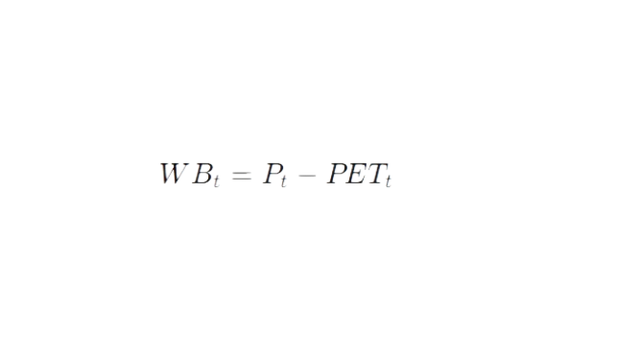
where WB_{t} represents climatic water balance in month t, P_{t}​ represents monthly precipitation, and PET_{t​} represents monthly potential evapotranspiration.
A three-month accumulated climatic water balance was subsequently calculated:
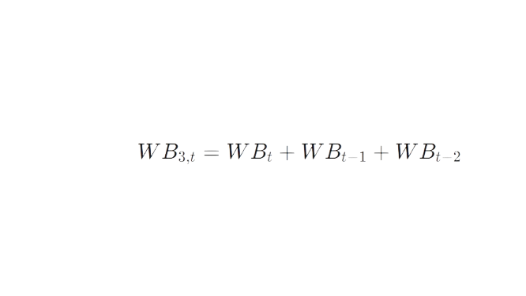
The three-month accumulation was used to represent short-term antecedent moisture conditions and to reduce reliance on individual-month anomalies.

3.5 Standardized Water-Balance Anomaly
The forecasting target was constructed by standardizing the three-month climatic water balance relative to the historical conditions of the corresponding calendar month.
To avoid future-information leakage, climatological means and standard deviations were calculated using training-period observations only, covering January 2015 to December 2021.
For each calendar month m, the training-period mean and standard deviation of the three-month water balance were calculated as:
μWB3,m​
and
σWB3,m​
respectively.
The standardized water-balance anomaly was then calculated as:
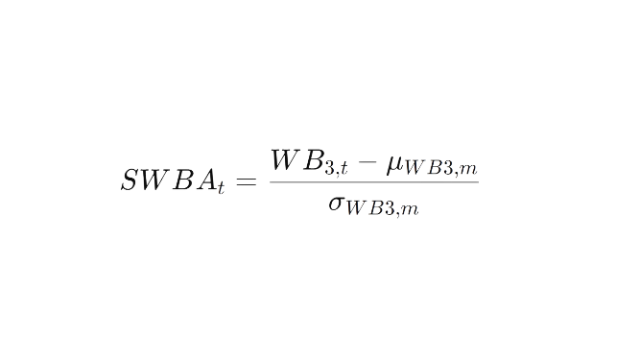
where SWBAt​ represents the standardized three-month climatic water-balance anomaly for observation t.
A value of zero therefore represents conditions close to the training-period climatological norm for that calendar month. Negative values represent drier-than-normal water-balance conditions, while positive values represent wetter-than-normal conditions.
The standardization differs from SPEI because no probability distribution was fitted prior to transformation. The resulting indicator was therefore interpreted as a standardized climatic water-balance anomaly rather than as formal SPEI.

3.6 Temporal Feature Engineering
Hydroclimatic conditions exhibit substantial temporal persistence. Environmental conditions during preceding months may influence soil moisture, runoff, evapotranspiration, and water availability in subsequent months.
One-, two-, and three-month lagged variables were therefore generated for the principal environmental predictors. For a predictor X, the lagged features were represented as:
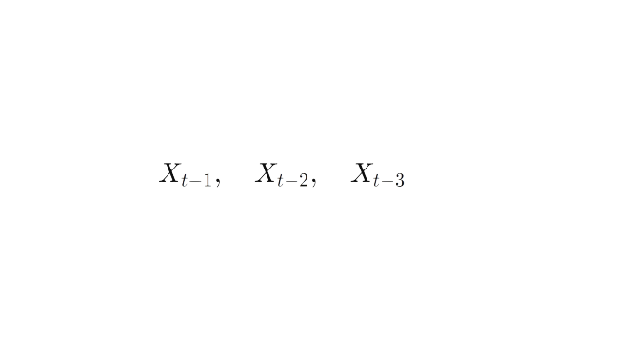
In addition, accumulated precipitation and PET variables were generated over three- and six-month periods to represent longer-term antecedent conditions.
Seasonality was represented using cyclical month transformations:
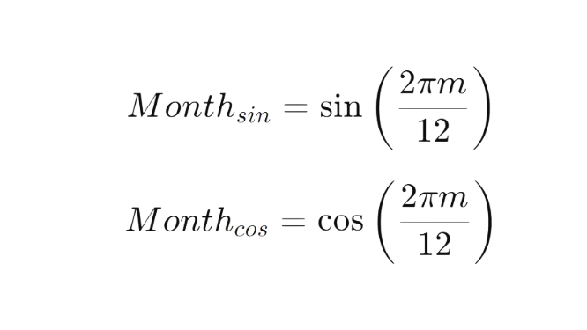
where m represents the calendar month.

3.7 One-Month-Ahead Forecast Target
The principal methodological change from contemporaneous prediction to true forecasting was achieved by shifting the standardized water-balance target one month forward.
The final forecasting relationship was:
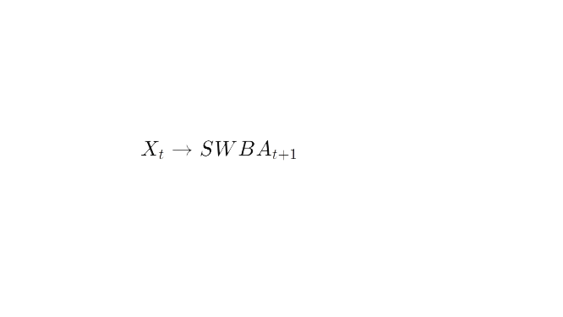
where Xt​ represents the environmental information available at month t, and SWBAt+1​ represents the water-balance anomaly in the following month.
This allowed current-month environmental conditions to be used legitimately as predictors because the predicted outcome had not yet occurred.
The final observation in December 2025 could not be used as an input for forecasting January 2026 because the corresponding target was unavailable.

3.8 Prevention of Data Leakage
Several safeguards were implemented to prevent information from the future or from the target construction process from influencing model development.
First, variables directly associated with the calculation of the standardized water-balance indicator were excluded from the predictor matrix. These included monthly water balance, three- and six-month water-balance variables, and the climatological means and standard deviations used in standardization.
Second, the climatic reference means and standard deviations were calculated using only the training-period data rather than the complete 2015–2025 dataset.
Third, feature ranking was conducted using training observations only.
Fourth, the independent 2024–2025 test period was not used to select the number of predictors or the Ridge regularization parameter.
These procedures reduced the risk of overly optimistic evaluation caused by direct or indirect information leakage.

3.9 Chronological Data Partitioning
The observations were divided chronologically rather than randomly.
The initial development periods were:
Dataset | Forecast Period | Purpose
Training | July 2015 – December 2021 | Feature ranking and model fitting
Validation | January 2022 – December 2023 | Feature-count and hyperparameter selection
Test | January 2024 – December 2025 | Final independent evaluation
The final model was subsequently refitted using the combined training and validation observations, producing 102 development observations, while the independent test set contained 24 monthly forecasts.
Chronological splitting was chosen because random splitting could allow later observations to inform predictions of earlier observations, which would not represent a realistic forecasting application.

3.10 Feature Selection
Candidate predictors were ranked using the absolute Pearson correlation between each predictor and the one-month-ahead target within the training period only.
The feature-selection score for predictor Xj​ was:
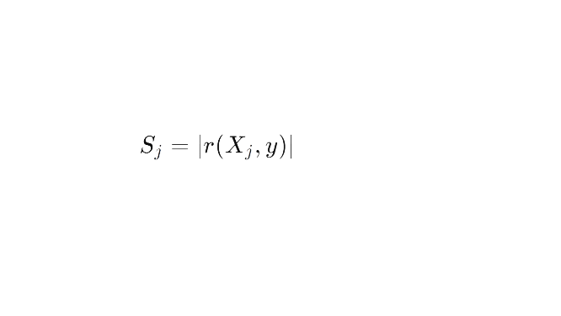
where y represents the one-month-ahead standardized water-balance target.
Candidate subsets containing 5, 10, 15, 20, 30, 40, and 50 predictors were evaluated on the validation period.
The 15-feature configuration produced the lowest validation RMSE and was therefore selected.
The final predictors were:
- Soil moisture layer 1 lagged by one month;
- Precipitation lagged by one month;
- Current PET;
- Soil moisture layer 2 lagged by one month;
- Current precipitation;
- Current soil moisture layer 2;
- Three-month accumulated precipitation;
- Current soil moisture layer 1;
- PET lagged by one month;
- Maximum temperature;
- Surface runoff lagged by one month;
- Runoff lagged by one month;
- Three-month accumulated PET;
- Current solar radiation; and
- Solar radiation lagged by one month.

3.11 Multicollinearity and Regularization
The earlier high-dimensional predictor set exhibited substantial multicollinearity because it contained multiple current, lagged, and accumulated forms of physically related environmental variables.
This provided an important methodological motivation for Ridge Regression. Ridge introduces an L2 regularization penalty that shrinks regression coefficients and reduces instability associated with correlated predictors.
The Ridge objective function is:
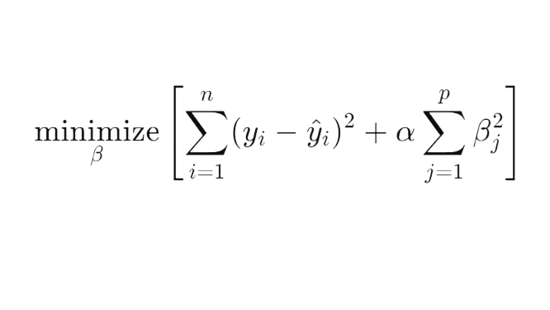
where α determines the strength of regularization.

3.12 Model Preprocessing
The final model was implemented as a Scikit-learn pipeline consisting of:
Median Imputation → Standardization → Ridge Regression
A median imputation step was retained within the Scikit-learn pipeline as a robustness safeguard. However, after temporal-history filtering, the final modelling dataset contained no missing predictor values. Consequently, the imputation step did not alter the observations used in the reported analysis.
StandardScaler was subsequently applied so that each predictor was placed on a comparable standardized scale. This was important because Ridge penalizes coefficient magnitudes and the environmental predictors were originally measured using different units.

3.13 Hyperparameter Selection
Ridge alpha values ranging from 0.01 to 100 were evaluated using the validation period.
The minimum validation RMSE was obtained at:
α=0.05
with:
$MAE=0.9420$
$RMSE=1.3150$
and
R²=0.2500
The alpha value of 0.05 was therefore fixed before the independent test evaluation.

3.14 Baseline Forecasts
The final Ridge model was compared with two benchmark approaches.
The first was a persistence forecast, defined as:
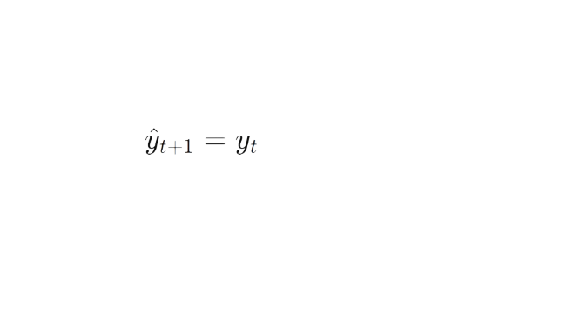
This assumes that the next month's standardized water-balance condition remains equal to the current month's observed condition.
The second was a climatological-normal forecast, defined as:
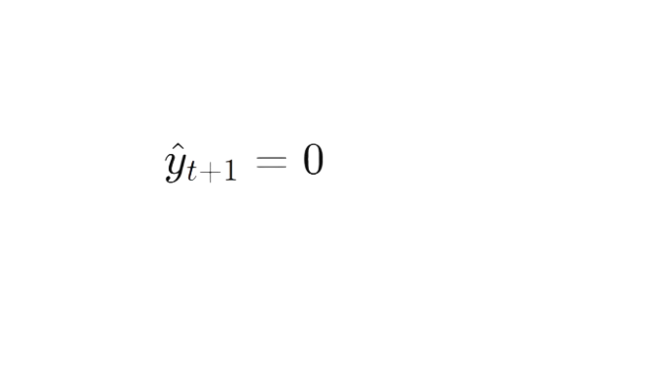
Because the target was standardized relative to the training-period monthly climatology, zero represented normal water-balance conditions.

3.15 Evaluation Metrics
Forecast performance was evaluated using Mean Absolute Error, Root Mean Squared Error, and the coefficient of determination.
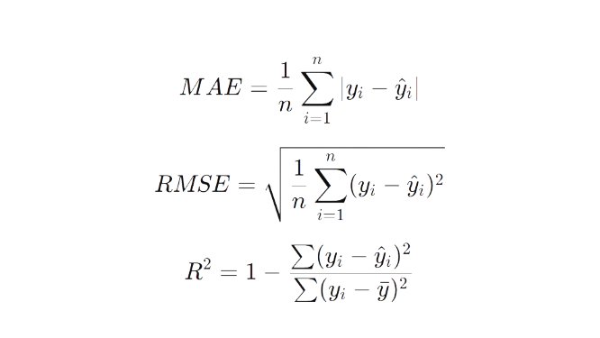
Forecast skill relative to the persistence and climatology baselines was additionally expressed as the percentage reduction in RMSE.

3.16 Residual and Sensitivity Analysis
Residuals were calculated as:
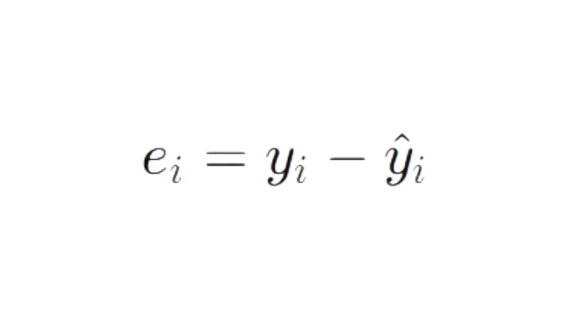
Positive residuals indicated that the model forecast was lower than the observed anomaly, while negative residuals indicated overprediction.
A sensitivity analysis was also conducted for May 2024 because it exhibited an unusually large standardized positive water-balance anomaly. The observation was retained in the official test evaluation; the sensitivity analysis was used only to quantify its influence on aggregate error metrics.
Performance was also evaluated separately for 2024 and 2025 and for observations with ∣SWBA∣≥2.

3.17 Model Interpretation
The standardized Ridge coefficients were examined after the final model was fitted.
Because predictor standardization preceded Ridge estimation, coefficient magnitudes provided a relative indication of predictive contribution within the final model.
However, coefficients were interpreted as predictive associations rather than causal effects, because hydroclimatic variables remain physically and statistically interrelated. This cautious interpretation is consistent with the broader scope of the study, which already distinguishes model-based associations from direct evidence of causation.

3.18 Chapter Summary
This chapter described a leakage-controlled, one-month-ahead machine learning forecasting framework based on monthly environmental observations.
The final model used 15 predictors and Ridge Regression with α=0.05. Environmental information from month t was used to forecast the standardized three-month climatic water-balance anomaly at month $t+1$.
Model development used chronological training and validation periods, while January 2024 to December 2025 was retained as an independent test period. The next chapter presents the model-selection results, independent forecast performance, baseline comparison, residual behaviour, sensitivity analysis, and predictor interpretation.

Chapter 4: Results and Discussion

4.1 Introduction
This chapter presents and interprets the results of the one-month-ahead water-balance forecasting framework. The analysis focuses on predictor selection, validation performance, independent test accuracy, forecast skill relative to persistence and climatology, temporal variability in performance, sensitivity to extreme observations, and the standardized coefficients of the final Ridge model.
The results are interpreted in the context of the principal objective of the study: determining whether environmental conditions observed in the current month contain useful information for forecasting hydroclimatic water-balance conditions one month in advance.

4.2 Feature Selection Results
The initial feature-ranking analysis indicated that antecedent soil moisture and precipitation contained some of the strongest linear associations with the one-month-ahead target.
The highest-ranked predictors were:

Rank | Predictor | Absolute training correlation
1 | Soil moisture layer 1 lag 1 | 0.3210
2 | Precipitation lag 1 | 0.3092
3 | PET | 0.2947
4 | Soil moisture layer 2 lag 1 | 0.2794
5 | Precipitation | 0.2734
6 | Soil moisture layer 2 | 0.2733
7 | 3-month precipitation | 0.2707
8 | Soil moisture layer 1 | 0.2522
9 | PET lag 1 | 0.2431
10 | Maximum temperature | 0.2382
The prominence of lagged soil moisture and precipitation suggests that antecedent moisture conditions contain useful predictive information for the following month's water balance.
This result is also hydrologically plausible. Soil moisture provides a measure of antecedent terrestrial water storage, while lagged precipitation represents recent atmospheric water input. Their importance indicates that the model is drawing predictive information from the persistence of hydroclimatic conditions rather than relying solely on contemporaneous temperature or precipitation.

4.3 Selection of Feature Count
Feature subsets ranging from 5 to 50 variables were evaluated using the validation period.
Features | MAE | RMSE | R²
15 | 0.9645 | 1.3234 | 0.2404
10 | 1.0335 | 1.3536 | 0.2054
20 | 1.0220 | 1.3703 | 0.1857
30 | 1.0221 | 1.4044 | 0.1446
40 | 1.1182 | 1.5062 | 0.0161
50 | 1.0849 | 1.4862 | 0.0421
5 | 1.1817 | 1.5226 | -0.0055
The 15-feature configuration produced the lowest validation RMSE. Increasing the predictor count beyond 15 did not improve forecast performance and generally resulted in poorer validation accuracy.
Figure 4.2 illustrates the validation RMSE obtained across the evaluated predictor-set sizes. Forecast error decreased substantially as the predictor set increased from 5 to 15 variables, with the minimum validation RMSE of 1.3234 occurring at 15 predictors. Increasing the predictor count beyond this point did not improve validation performance, supporting the selection of the 15-predictor configuration for subsequent Ridge hyperparameter tuning.
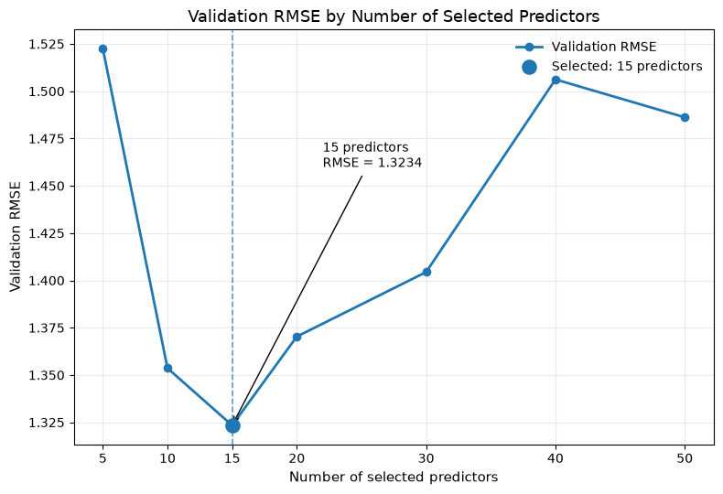Figure 4.2: Validation RMSE across the evaluated numbers of selected predictors. The 15-predictor configuration achieved the lowest validation RMSE (1.3234) and was therefore retained for subsequent Ridge Regression hyperparameter tuning.
This finding supports the use of a parsimonious predictor set. The earlier high-dimensional analysis demonstrated that many engineered environmental variables contained overlapping information. Reducing the model to 15 predictors retained the principal hydroclimatic signals while reducing unnecessary redundancy.

4.4 Ridge Hyperparameter Selection
The Ridge regularization parameter was selected using RMSE validation.
Alpha | MAE | RMSE | R²
0.05 | 0.9420 | 1.3150 | 0.2500
0.10 | 0.9419 | 1.3152 | 0.2499
0.01 | 0.9431 | 1.3152 | 0.2499
0.50 | 0.9482 | 1.3186 | 0.2459
1.00 | 0.9645 | 1.3234 | 0.2404
2.00 | 0.9828 | 1.3325 | 0.2300
5.00 | 1.0317 | 1.3539 | 0.2050
The smallest validation RMSE was achieved with α=0.05. The differences among 0.01, 0.05, and 0.10 were small, indicating that the model was relatively stable across weak levels of regularization.
Nevertheless, 0.05 was retained because RMSE had been specified as the principal validation criterion before independent testing.

4.5 Independent Test Performance
The final Ridge model was trained using the combined training and validation observations and evaluated on the independent January 2024–December 2025 period.
The final results were:
Model | MAE | RMSE | R²
Final Ridge t+1 | 0.9625 | 1.3906 | 0.2124
Persistence | 1.0290 | 1.7568 | -0.2570
Climatology | 1.1358 | 1.7589 | -0.2600
The Ridge model reduced MAE by 6.46% relative to persistence and reduced RMSE by 20.84%.
Relative to the climatological-normal forecast, Ridge reduced RMSE by 20.93%.
These results indicate that the selected environmental predictors provide useful forecast information beyond simple temporal persistence and climatological expectation.
The test-set R² of 0.2124 indicates that the Ridge forecasts reduced squared prediction error relative to predicting the test-set mean, corresponding to approximately 21% of test-set variance explained under the conventional R² interpretation. Although this represents modest explanatory power, the positive forecast skill relative to both baseline approaches is more relevant operationally because it demonstrates that the machine-learning framework improved one-month-ahead predictions over simpler forecasting strategies.

4.6 Temporal Variation in Forecast Accuracy
Model performance differed substantially between the two independent test years.
Year | MAE | RMSE | R² | Mean Residual | Maximum Error
2024 | 1.1069 | 1.7119 | 0.3140 | 0.5403 | 5.1248
2025 | 0.8181 | 0.9680 | -0.4790 | 0.5145 | 2.1688
The model achieved a lower RMSE in 2025 than in 2024. However, the negative 2025 R2 indicates that the forecasts did not explain the intermonthly variation in that year as effectively as a year-specific mean benchmark would have.
The baseline comparison provides additional insight.
Year | Ridge RMSE | Persistence RMSE | Climatology RMSE
2024 | 1.7119 | 2.3399 | 2.2339
2025 | 0.9680 | 0.8352 | 1.0940
Ridge clearly outperformed both baselines during 2024. In contrast, persistence provided lower RMSE than Ridge in 2025.
This result demonstrates that the model's predictive advantage is not uniform across all periods. In years characterized by strong shifts in water-balance conditions, environmental predictors may provide information beyond persistence. During periods of greater temporal continuity, however, persistence may remain difficult to outperform.
Figure 4.3 presents the month-by-month behaviour of the Ridge forecasts relative to the observed SWBA and benchmark forecasts during the independent test period. The Ridge model broadly tracked several moderate fluctuations in SWBA but substantially underestimated the exceptional positive anomaly observed in May 2024. The persistence baseline also responded poorly to this abrupt change, carrying the preceding extreme condition into the subsequent forecast month. These patterns illustrate why aggregate performance metrics should be considered alongside the temporal behaviour of individual forecasts.
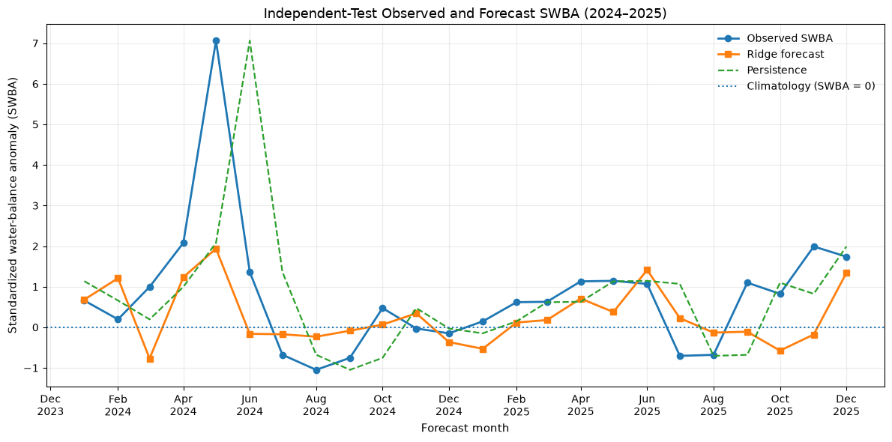Figure 4.3: Observed and forecast standardized water-balance anomaly (SWBA) during the independent January 2024–December 2025 test period. Ridge Regression forecasts are compared with observed SWBA, a one-month persistence baseline, and the climatological baseline (SWBA = 0).

4.7 Residual Behaviour
The final model produced a mean residual of:
0.5274
with a residual standard deviation of 1.3144.
Because residuals were defined as observed minus forecast values, the positive mean indicates that the model tended to underpredict positive standardized water-balance anomalies.
The largest absolute error was 5.1248, corresponding to May 2024.
The observed May 2024 anomaly was:
7.0614
whereas the Ridge forecast was:
1.9365
This represented an unusually large positive departure from the training-period climatology and substantially exceeded the range of most other observations.
Figure 4.4 further illustrates the relationship between observed and forecast SWBA values across the independent test period. Most monthly forecasts are concentrated relatively close to the 1:1 reference line, particularly for moderate SWBA values. However, the largest observed positive anomaly lies substantially below the 1:1 line, demonstrating the model's pronounced underprediction of the May 2024 extreme. The figure therefore reinforces the residual analysis by showing that forecast errors were considerably larger for the most extreme positive anomaly than for most moderate observations.
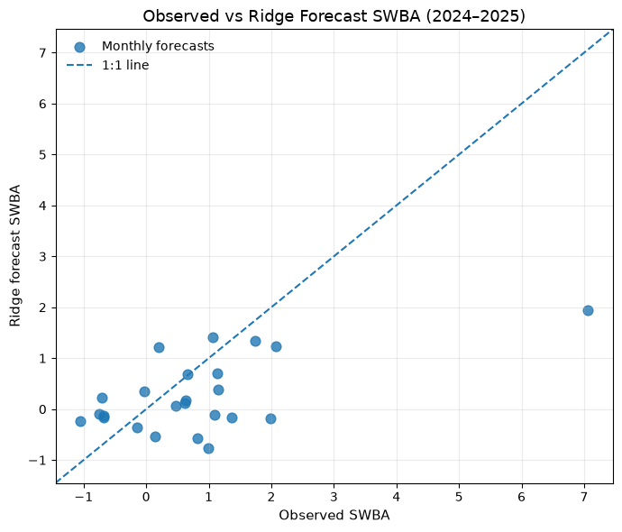Figure 4.4: Relationship between observed and Ridge-forecast standardized water-balance anomaly (SWBA) during the independent January 2024–December 2025 test period. The dashed 1:1 line represents perfect agreement between observed and forecast values.
The tendency to forecast values closer to the centre of the distribution is consistent with regularized regression, which generally produces smoother predictions and may have difficulty reproducing abrupt extremes not strongly represented in the development data.

4.8 Sensitivity to the May 2024 Extreme
May 2024 exerted a substantial influence on aggregate error metrics.
Evaluation | N | MAE | RMSE | R²
Official test-all observations | 24 | 0.9625 | 1.3906 | 0.2124
Sensitivity-excluding May 2024 | 23 | 0.7815 | 0.9360 | -0.1192
When May 2024 was excluded for diagnostic purposes, MAE decreased by 18.80%, while RMSE decreased by 32.69%.
The observation was retained in the official evaluation because excluding difficult hydroclimatic events would produce an overly optimistic representation of operational performance.
The sensitivity analysis instead demonstrates that a substantial portion of the total test RMSE was associated with one unusually strong positive anomaly.
Interestingly, R² became negative when the observation was removed. This occurs because R² depends not only on prediction error but also on the variance of the observed series. The extreme May 2024 value substantially increases the variance of the test target, thereby changing the denominator used in the R calculation. This illustrates why RMSE, MAE, baseline skill, and event-level errors should be interpreted alongside R² rather than relying on R² alone.

4.9 Performance During Extreme and Non-Extreme Conditions
Two test observations had absolute standardized anomalies equal to or greater than 2.
Their forecasting errors were substantially larger than those for the remaining observations.
Condition | MAE | RMSE
( | SWBA | \ge2)
( | SWBA | <2)
The two extreme observations occurred in April and May 2024.
The April 2024 observed anomaly was 2.0794 compared with a forecast of 1.2341. May 2024 exhibited a much larger anomaly of 7.0614 compared with a forecast of 1.9365.
These results indicate that the model performs considerably better under non-extreme hydroclimatic conditions than during unusually large departures from the training climatology.
For operational early-warning applications, this limitation is important because extreme conditions may be among the events of greatest management interest.

4.10 Final Ridge Coefficients
The standardized Ridge coefficients are presented below.
Rank | Predictor | Coefficient | Absolute coefficient
1 | Soil moisture layer 1 lag 1 | 1.1918 | 1.1918
2 | PET, 3-month | -0.9542 | 0.9542
3 | Precipitation | 0.8025 | 0.8025
4 | PET lag 1 | 0.7738 | 0.7738
5 | Solar radiation lag 1 | -0.6897 | 0.6897
6 | Precipitation, 3-month | -0.6225 | 0.6225
7 | Precipitation lag 1 | 0.5638 | 0.5638
8 | Soil moisture layer 2 lag 1 | -0.4565 | 0.4565
9 | Surface runoff lag 1 | -0.4096 | 0.4096
10 | PET | 0.3647 | 0.3647
11 | Maximum temperature | -0.2961 | 0.2961
12 | Runoff lag 1 | 0.2441 | 0.2441
13 | Soil moisture layer 1 | 0.1201 | 0.1201
14 | Solar radiation | -0.0837 | 0.0837
15 | Soil moisture layer 2 | -0.0783 | 0.0783
The largest standardized coefficient was associated with lagged upper-layer soil moisture, suggesting that antecedent near-surface moisture conditions carry substantial information about the following month's water-balance anomaly.
Figure 4.5 provides a visual comparison of the standardized coefficients of the final Ridge Regression model. Because all predictors were standardized before model fitting, coefficient magnitudes can be compared as indicators of relative predictive influence within the fitted model. The largest positive coefficient was associated with one-month-lagged upper-layer soil moisture, while three-month PET exhibited the largest negative coefficient. The mixture of positive and negative coefficients across related hydroclimatic variables should be interpreted as multivariable predictive associations rather than independent causal effects.
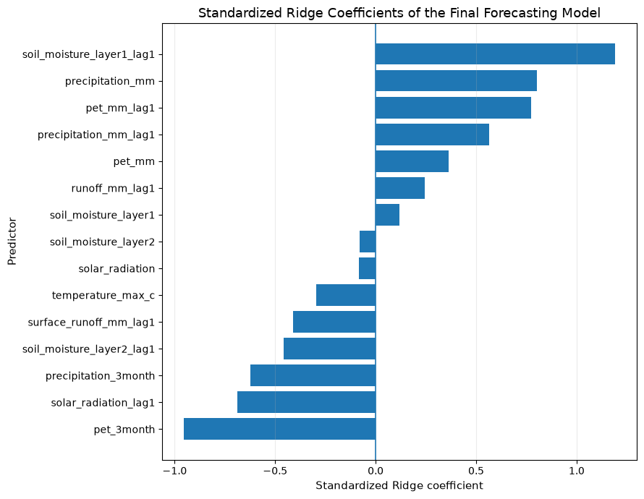Figure 4.5: Standardized coefficients of the 15 predictors retained in the final Ridge Regression model. Positive coefficients indicate positive conditional associations with one-month-ahead SWBA forecasts, while negative coefficients indicate negative conditional associations. Coefficient magnitudes represent relative predictive influence after predictor standardization and should not be interpreted as causal effects.
Three-month PET had the second-largest coefficient magnitude, followed by current precipitation, lagged PET, lagged solar radiation, and accumulated precipitation.
The importance of both current and lagged variables supports the central assumption of the study that water-balance conditions possess temporal memory.
However, coefficient direction must be interpreted cautiously. The model contains correlated environmental variables and several predictors represent different temporal expressions of related physical processes. Consequently, a positive coefficient should not be interpreted as evidence that the predictor independently causes wetter conditions, nor should a negative coefficient automatically imply a direct drying effect.
Instead, the coefficients describe each variable's conditional contribution within the fitted regularized model.

4.11 Hydroclimatic Interpretation
The final predictor set suggests that antecedent terrestrial moisture, rainfall, and atmospheric evaporative demand jointly provide predictive information about one-month-ahead water-balance conditions.
Lagged soil moisture emerged as the strongest individual predictor. This finding is consistent with the concept of hydrological memory: soil-water conditions do not immediately reset at monthly boundaries and therefore provide information about subsequent hydroclimatic conditions.
Precipitation also appeared in current, lagged, and accumulated forms. This indicates that both immediate rainfall and antecedent rainfall conditions contribute to future water balance.
PET and maximum temperature represent atmospheric water demand. Their presence indicates that water-balance forecasting requires not only information about water input but also information about conditions influencing potential atmospheric loss.
Solar radiation contributes additional information related to surface energy availability, while runoff and surface runoff describe hydrological response following precipitation and storage processes.
The final model therefore supports a multivariate interpretation of water-balance dynamics rather than a precipitation-only explanation.

4.12 Comparison with the Study Objectives
The findings address the research objectives established in Chapter 1.
The selected predictor set retained several lagged and accumulated variables, including lagged soil moisture, lagged precipitation, lagged PET, three-month precipitation, three-month PET, lagged runoff, and lagged solar radiation. This indicates that antecedent and accumulated hydroclimatic conditions provided useful predictive signals within the final one-month-ahead forecasting model.
Feature-count evaluation demonstrated that a 15-variable subset provided stronger validation performance than larger predictor sets, while Ridge regularization addressed the correlated nature of the hydroclimatic predictors.
The independent test evaluation demonstrated measurable one-month-ahead forecast skill relative to both persistence and climatology.
Finally, standardized coefficient analysis identified soil moisture, precipitation, PET, solar radiation, temperature, and runoff-related variables as important components of the final forecasting model.

4.13 Limitations of the Forecasting Framework
Several limitations should be considered when interpreting the results.
First, the modelling dataset is relatively small. The final independent test contains only 24 monthly observations, limiting the precision with which long-term forecast performance can be estimated.
Second, the model shows substantially reduced accuracy during extreme anomalies. This limitation is particularly evident in May 2024.
Third, forecast performance varies between years. Ridge substantially outperformed persistence in 2024 but did not outperform it in 2025.
Fourth, the model uses a standardized water-balance anomaly rather than direct measurements of reservoir storage, streamflow, water demand, or household water availability. The forecasts should therefore be interpreted as hydroclimatic indicators rather than direct predictions of water-security outcomes.
Finally, Ridge Regression models primarily linear conditional relationships. Although temporal feature engineering allows it to incorporate antecedent conditions, some nonlinear hydroclimatic interactions may remain insufficiently represented.
Feature selection and hyperparameter tuning relied on a single chronologically subsequent 24-month validation period. Although this preserved temporal ordering and protected the independent test set from model-selection decisions, the relatively short validation period may make the selected predictor count and regularization strength sensitive to the particular hydroclimatic conditions observed during 2022–2023. Future studies with longer records should consider rolling-origin or blocked time-series cross-validation to assess the stability of model-selection decisions.

4.14 Implications for Water-Resource Management
Despite these limitations, the model demonstrates that readily available environmental observations can provide measurable information about water-balance conditions one month in advance.
An RMSE reduction of approximately 21% relative to persistence and climatology suggests that combining soil moisture, precipitation, PET, temperature, radiation, and hydrological-response variables can improve short-term environmental forecasting.
Such forecasts could eventually contribute to decision-support systems for monitoring evolving hydroclimatic conditions. However, the observed underprediction of extreme anomalies indicates that predictions should be used alongside conventional monitoring, expert interpretation, and other early-warning information rather than as a stand-alone decision rule.

4.15 Chapter Summary
This chapter evaluated the final leakage-controlled one-month-ahead Ridge forecasting framework.
A 15-feature model with α=0.05 was selected using the validation period. On the independent 2024–2025 test period, the model achieved an MAE of 0.9625, RMSE of 1.3906, and R² of 0.2124.
The model reduced RMSE by 20.84% relative to persistence and 20.93% relative to climatological-normal forecasting, demonstrating measurable out-of-sample forecast skill.
However, model performance was not uniform. The largest error occurred during an extreme positive water-balance anomaly in May 2024, and the model performed substantially better during non-extreme conditions than during observations with ∣SWBA∣≥2.
The standardized coefficients indicated that lagged soil moisture, PET, precipitation, solar radiation, runoff, and temperature collectively contributed to the forecasts. These findings support the use of multi-variable and temporally informed environmental prediction while also highlighting the continuing difficulty of anticipating abrupt hydroclimatic extremes.
The next chapter summarizes the principal findings, discusses their implications for climate-resilient water management, and presents recommendations for future research and operational development.

Chapter 5: Conclusion and Recommendations

5.1 Introduction
This chapter presents the main conclusions arising from the development and evaluation of the one-month-ahead water-stress forecasting framework. It summarizes the principal findings, discusses their implications for climate-resilient water-resource management, identifies the main limitations of the study, and provides recommendations for future methodological development and operational application.
The study was motivated by the need to move beyond retrospective hydroclimatic monitoring toward predictive approaches capable of identifying emerging water-balance conditions before they fully develop. By integrating precipitation, potential evapotranspiration, soil moisture, temperature, solar radiation, runoff, and temporally engineered predictors, the research examined whether machine learning could provide useful one-month-ahead forecast skill under the data conditions available for Eswatini.

5.2 Summary of the Study
The study developed a monthly machine learning framework based on environmental and climate-derived predictors covering the period from 2015 to 2025. A standardized three-month climatic water-balance anomaly was constructed from precipitation and potential evapotranspiration and used as the forecasting target.
To reduce future-information leakage, the climatological mean and standard deviation used to standardize the three-month water balance were estimated from the training period only. The target was subsequently shifted one month forward so that environmental conditions observed at month t were used to predict the standardized water-balance anomaly at month t+1.
Temporal feature engineering incorporated current environmental variables, one- to three-month lags, accumulated precipitation and PET indicators, and seasonal representations. The data were separated chronologically into training, validation, and independent testing periods. Predictor ranking and model selection were conducted without using the final 2024–2025 test period.
Feature-count evaluation identified a 15-predictor configuration as the most effective validation model. Ridge Regression was selected because of the substantial correlation among hydroclimatic predictors, and the final regularization parameter was fixed at α=0.05.
The final model was then evaluated on 24 unseen monthly observations covering January 2024 to December 2025 and compared with persistence and climatological-normal baseline forecasts.

5.3 Summary of Major Findings
The first major finding was that useful one-month-ahead predictive information exists within antecedent hydroclimatic conditions. The most informative predictors included lagged upper-layer soil moisture, lagged precipitation, PET, current precipitation, accumulated precipitation, lagged PET, maximum temperature, solar radiation, runoff, and surface runoff.
The prominence of lagged soil moisture and precipitation is consistent with temporal persistence in hydroclimatic conditions, indicating that antecedent moisture and precipitation states contained useful predictive information for the following month’s standardized water-balance anomaly.
Second, increasing the number of predictors did not continuously improve forecasting performance. The 15-feature model outperformed larger 20-, 30-, 40-, and 50-feature configurations during validation. This finding demonstrated that a relatively compact set of predictors could preserve useful environmental information while reducing the redundancy associated with highly correlated lagged variables.
Third, the final Ridge Regression model demonstrated measurable forecast skill on the independent test period. The model achieved:
$MAE=0.9625$
$RMSE=1.3906$
and
R²=0.2124
The persistence baseline produced an RMSE of 1.7568, while the climatological-normal baseline produced an RMSE of 1.7589. The Ridge model therefore reduced RMSE by 20.84% relative to persistence and 20.93% relative to climatology.
These improvements indicate that the environmental predictors contributed forecasting information beyond simply assuming that current water-balance conditions would persist into the following month.
Fourth, model performance varied substantially through time. Ridge clearly outperformed persistence during 2024, but persistence achieved lower RMSE during 2025. The forecasting advantage of the machine learning model was therefore not uniform across all periods.
Fifth, the model showed considerably weaker performance during extreme standardized water-balance anomalies. For observations with ∣SWBA∣≥2, RMSE increased to 3.6728 compared with 0.9399 for non-extreme observations. The strongest example occurred in May 2024, when the observed standardized water-balance anomaly reached 7.0614 but the model forecast was 1.9365.
Finally, the mean residual of 0.5274 indicated an overall tendency to underpredict high positive water-balance anomalies. This suggests that while Ridge Regression was effective at modelling ordinary hydroclimatic variation, its regularized linear structure tended to produce forecasts closer to the centre of the observed distribution and therefore struggled with abrupt extremes.

5.4 Conclusions
The results demonstrate that machine learning can provide useful short-term predictive information for hydroclimatic water-balance conditions using environmental observations available one month earlier.
The improvement of approximately 21% in RMSE relative to both persistence and climatology indicates that the final Ridge model captured relationships that were not represented by simple baseline forecasting approaches. This is particularly important because persistence can be a strong benchmark in environmental time series where neighbouring months are often highly correlated.
The study also demonstrates the importance of careful methodological design. The transition from contemporaneous prediction to true one-month-ahead forecasting produced a more realistic assessment of predictive capability. Similarly, calculating climatological standardization parameters from the training period only reduced the possibility of future-information leakage and strengthened the credibility of the independent evaluation.
The final 15-predictor structure further demonstrates that more environmental variables do not necessarily produce stronger forecasts. Redundant lagged and accumulated predictors can increase model complexity without increasing generalization performance. Feature selection and regularization therefore represent important components of machine learning workflows involving relatively small hydroclimatic datasets.
Overall, the findings support the conclusion that antecedent soil moisture, precipitation, atmospheric evaporative demand, temperature, surface-energy conditions, and runoff collectively provide useful information for forecasting short-term departures in climatic water balance.
However, the model should not be interpreted as a complete operational water-stress early-warning system. Its skill is modest, varies between years, and decreases substantially during extreme events. The framework is therefore best viewed as an initial predictive decision-support approach that demonstrates the potential value of integrated environmental data while identifying important areas requiring further development.

5.5 Implications for Water-Resource Management
The forecasting framework has several potential implications for climate-resilient water-resource management.
First, the results demonstrate that multi-source environmental datasets can support predictive analysis even where long, dense ground-station records are limited. The use of remotely sensed precipitation and climate-reanalysis variables may therefore provide a practical complement to existing monitoring infrastructure.
Second, the prominence of antecedent soil moisture and precipitation indicates that early-warning systems should not rely only on current rainfall conditions. Information concerning accumulated moisture conditions may provide additional warning of developing hydroclimatic stress.
Third, the forecasting horizon of one month may have practical value for short-term planning. Although the model is not sufficiently accurate to support deterministic decision-making on its own, one-month-ahead information could potentially contribute to broader decision-support processes involving agricultural planning, water allocation, drought preparedness, and reservoir monitoring.
Fourth, the observed difficulty in predicting extreme conditions demonstrates that forecasts should be used together with real-time monitoring and expert interpretation. An operational system should therefore combine machine learning output with other indicators rather than treating a single statistical prediction as definitive evidence of future water availability.

5.6 Limitations of the Study
Several limitations affect the interpretation and generalizability of the findings.
The first limitation is the relatively short observation period. The modelling dataset covers approximately eleven years, while the final independent evaluation contains only 24 monthly forecasts. This limits the number of drought, wet, and transition events available for model learning and testing.
Second, the environmental predictors exhibit substantial temporal and physical correlation. Although Ridge Regression reduces instability associated with multicollinearity, individual coefficients cannot be interpreted as isolated physical effects.
Third, the standardized water-balance anomaly used in the study represents hydroclimatic conditions rather than direct socioeconomic water stress. It does not explicitly incorporate reservoir storage, groundwater availability, irrigation demand, household consumption, infrastructure constraints, or institutional water allocation.
Fourth, the model was developed as a temporal rather than fully spatial forecasting framework. The current results therefore do not quantify differences in forecast performance among the Highveld, Middleveld, Lowveld, and Lubombo regions.
Fifth, the model exhibits reduced skill during unusually extreme conditions. Such events are particularly important for climate-risk management, meaning that improved extreme-event forecasting should remain a priority for future model development.
Finally, Ridge Regression primarily models linear conditional relationships. Although lagged and accumulated predictors allow the framework to represent temporal dependence, complex nonlinear interactions may remain inadequately captured.

5.7 Recommendations
Based on the findings of the study, several recommendations are proposed.

5.7.1 Recommendations for Operational Application
Future water-stress monitoring systems in Eswatini should consider integrating satellite and reanalysis data with existing ground-based observations. The present findings indicate that precipitation, soil moisture, PET, temperature, radiation, and runoff contain complementary information that may improve short-term warning capability.
Machine learning forecasts should be incorporated as one component within a multi-indicator early-warning framework rather than used independently. Forecast uncertainty, persistence, climatological conditions, and real-time observations should be considered jointly when supporting water-management decisions.
Particular attention should be given to the monitoring of antecedent soil moisture and accumulated precipitation, as these variables provided some of the strongest predictive information within the final model.

5.7.2 Recommendations for Methodological Improvement
Future studies should evaluate additional modelling approaches while preserving the leakage-control and chronological evaluation principles established in this study.
Tree-based models such as Random Forest, Gradient Boosting, and XGBoost may be useful for capturing nonlinear relationships, particularly if larger datasets become available. Deep-learning models such as LSTM may also be considered where substantially longer temporal records or multiple spatial observation points increase the available sample size.
Model evaluation should continue to include strong baseline forecasts. Persistence and climatology provide valuable reference points and help determine whether additional modelling complexity produces meaningful predictive benefit.
Future studies should also consider probabilistic forecasting approaches. Rather than producing a single expected value, probabilistic forecasts could provide uncertainty intervals or probabilities of exceeding predefined dry or wet anomaly thresholds.

5.7.3 Recommendations for Extreme-Event Forecasting
The substantial reduction in accuracy during extreme events indicates that future research should explicitly investigate forecasting approaches designed for rare hydroclimatic anomalies.
Possible approaches include weighted loss functions, event-based modelling, anomaly detection, quantile regression, and ensemble forecasting. Expanding the historical record would also increase the number of extreme events available for training.
The May 2024 anomaly demonstrates the importance of evaluating models at the event level rather than relying exclusively on average error metrics.

5.7.4 Recommendations for Spatial Extension
Future research should extend the current temporal framework to spatially resolved environmental observations across Eswatini.
Grid-based or catchment-based modelling would allow forecast skill to be assessed separately for the Highveld, Middleveld, Lowveld, and Lubombo Plateau. Such an extension could identify locations where water-stress predictability is greater or lower and could support geographically targeted early-warning strategies.
Spatial extension would also permit integration of vegetation indices, elevation, land cover, river-basin characteristics, and additional remote-sensing variables.

5.7.5 Recommendations for Data Expansion
Longer environmental time series should be incorporated where possible. Extending precipitation and climate-reanalysis data further into the historical period would increase the number of seasonal cycles and extreme events available for model development.
Where reliable ground observations are available, future work should validate satellite and reanalysis variables against meteorological stations, streamflow records, reservoir levels, and soil-moisture observations.
Linking the standardized climatic water-balance anomaly to actual reservoir and agricultural impacts would also strengthen the practical interpretation of forecasts.

5.8 Contribution of the Study
This research makes three principal contributions.
First, it demonstrates a reproducible one-month-ahead machine learning framework based on multi-source hydroclimatic predictors and a leakage-controlled chronological evaluation strategy.
Second, it demonstrates that a reproducible, leakage-controlled catchment-scale forecasting workflow can achieve lower aggregate independent-test RMSE than both persistence and climatological baselines, with an approximately 21% reduction over the full 24-month test period.
Third, it identifies antecedent soil moisture, precipitation, evapotranspiration, radiation, temperature, and runoff as useful predictive signals while demonstrating that model performance deteriorates considerably during extreme water-balance anomalies.
These contributions provide a foundation for future development of more spatially detailed, probabilistic, and operational hydroclimatic forecasting systems.

5.9 Final Conclusion
Eswatini's vulnerability to climate variability creates a continuing need for predictive approaches that complement conventional hydroclimatic monitoring. This study demonstrates that multi-source environmental information can provide measurable one-month-ahead forecasting skill when combined through a carefully designed machine learning framework.
Across the full independent 2024–2025 test period, the final Ridge Regression model reduced aggregate RMSE by approximately 21% relative to persistence and climatology, although persistence outperformed Ridge during 2025 when the years were examined separately. The results demonstrate that antecedent soil moisture, precipitation, PET, temperature, radiation, and hydrological-response variables collectively contain information relevant to subsequent water-balance conditions.
At the same time, the findings highlight the limits of current predictive capability. Forecast skill varied between years, and extreme anomalies remained substantially more difficult to predict than ordinary conditions.
The study therefore concludes that machine learning provides a promising complementary tool for short-term hydroclimatic forecasting in Eswatini, but operational implementation should prioritize uncertainty communication, continued environmental monitoring, longer datasets, and improved modelling of extreme events. Further development of spatially resolved and probabilistic forecasting systems could strengthen the contribution of such tools to climate-resilient water-resource management.

References
Afan, H. A., Almawla, A. S., Al-Hadeethi, B., Khaleel, F., AbdUlameer, A. H., Khan, M. M. H., Ma’arof, M. I. N., & Kamel, A. H. (2024). LSTM model integrated remote sensing data for drought prediction: A study on climate change impacts on water availability in the arid region. Water, 16(19), 2799. https://doi.org/10.3390/w16192799
Britton, A., Graham, G., & Woloszyn, M. (2024). Exploring relationships between drought indices and ecological drought impacts using machine learning and explainable AI. Journal of Applied and Service Climatology, 2024(005). https://doi.org/10.46275/JOASC.2024.09.001
Chen, Y., Wu, H., Xie, N., Liang, X., Jiang, L., Qiu, M., & Li, Y. (2025). STAT-LSTM: A multivariate spatiotemporal feature aggregation model for SPEI-based drought prediction. Earth Science Informatics, 18, 289. https://doi.org/10.1007/s12145-025-01813-0
Chivangulula, F. M., Amraoui, M., & Pereira, M. G. (2023). The drought regime in Southern Africa: A systematic review. Climate, 11(7), 147. https://doi.org/10.3390/cli11070147
Contreras, S., Nobre, G. G., Fernández-Rodríguez, A., Khanal, S., Nolet, C., & Simons, G. (2022). InfoSequia: Towards an operational satellite-based drought early warning and forecasting system for quantifying risks of crop and water supply by using machine learning and remote sensing. EGU General Assembly 2022, EGU22-8016. https://doi.org/10.5194/egusphere-egu22-8016
Eswatini Government & United Nations Convention to Combat Desertification (UNCCD). (2020). Eswatini National Drought Plan. United Nations Convention to Combat Desertification.
Fashoto, S. G., Mashwama, P., Nxumalo, M. N., Akinnuwesi, B. A., Mbunge, E., & Metfula, A. S. (2025). Anticipating drought: Enhancing prediction models and assessing environmental impact in Eswatini’s Maguga Basin. International Journal of Information Technology. https://doi.org/10.1007/s41870-025-02750-3
Funk, C., Peterson, P., Landsfeld, M., Pedreros, D., Verdin, J., Shukla, S., Husak, G., Rowland, J., Harrison, L., Hoell, A., & Michaelsen, J. (2015). The climate hazards infrared precipitation with stations—a new environmental record for monitoring extremes. Scientific Data, 2, 150066. https://doi.org/10.1038/sdata.2015.66
Gujarati, D. N., & Porter, D. C. (2009). Basic econometrics (5th ed.). McGraw-Hill.
Hadebe, S. B. H., & Dube, L. T. (2024). Climate variability over Southern Africa and implications for water resources: A review. Advances in Hydrology & Meteorology, 1(4), Article 000517. https://doi.org/10.33552/AHM.2024.01.000517
Lawal, S., Sitch, S., Lombardozzi, D., Nabel, J. E. M. S., Wey, H.-W., Friedlingstein, P., Tian, H., & Hewitson, B. (2022). Investigating the response of leaf area index to droughts in southern African vegetation using observations and model simulations. Hydrology and Earth System Sciences, 26(8), 2045–2071. https://doi.org/10.5194/hess-26-2045-2022

Muñoz-Sabater, J., Dutra, E., Agustí-Panareda, A., Albergel, C., Arduini, G., Balsamo, G., Boussetta, S., Choulga, M., Harrigan, S., Hersbach, H., Martens, B., Miralles, D. G., Piles, M., Rodríguez-Fernández, N. J., Zsoter, E., Buontempo, C., & Thépaut, J.-N. (2021). ERA5-Land: A state-of-the-art global reanalysis dataset for land applications. Earth System Science Data, 13(9), 4349–4383. https://doi.org/10.5194/essd-13-4349-2021
Nyamane, S., Abd Elbasit, M. A. M., & Obagbuwa, I. C. (2024). Harnessing deep learning for meteorological drought forecasts in the Northern Cape, South Africa. International Journal of Intelligent Systems, 2024, 7562587. https://doi.org/10.1155/2024/7562587
Phiri, R., Esiefarienrhe, B. M., & Obagbuwa, I. C. (2025). Medium range meteorological drought prediction based on SPEI-3 using ensemble machine learning and deep learning in North West Province, South Africa. Indonesian Journal of Data and Science, 6(3), 393–411. https://doi.org/10.56705/ijodas.v6i3.354
World Bank. (2021). Climate Change Knowledge Portal: Eswatini. World Bank.

